Министерство образования и молодежной политики Свердловской области

ГАПОУ СО «Екатеринбургский колледж транспортного строительства»

Отчет по ТРПО. Лабораторная работа   
**Введение в XAML и WPF**

Выполнили: Максимов К. Э.

Группа: ПР-31

Преподаватель: Бушуева Е. В.

2024

MainWindow  
  
<Window x:Class="Lab_1_WPF.MainWindow"

xmlns="http://schemas.microsoft.com/winfx/2006/xaml/presentation"

xmlns:x="http://schemas.microsoft.com/winfx/2006/xaml"

xmlns:d="http://schemas.microsoft.com/expression/blend/2008"

xmlns:mc="http://schemas.openxmlformats.org/markup-compatibility/2006"

xmlns:local="clr-namespace:Lab_1_WPF"

mc:Ignorable="d"

Title="MainWindow" Height="450" Width="800">

<Grid>

<Button x:Name="Btn1"

HorizontalAlignment="Center"

VerticalAlignment="Center"

Width="150"

Height="30"

FontSize="17"

Content="Обычная кнопка"

Foreground="#f0f0f0"

BorderBrush="#303030">

<Button.Background>

<LinearGradientBrush>

<LinearGradientBrush.GradientStops>

<GradientStop Color="LightBlue" Offset="0"/>

<GradientStop Color="DarkBlue" Offset="1"/>

</LinearGradientBrush.GradientStops>

</LinearGradientBrush>

</Button.Background>

</Button>

</Grid>

</Window>  
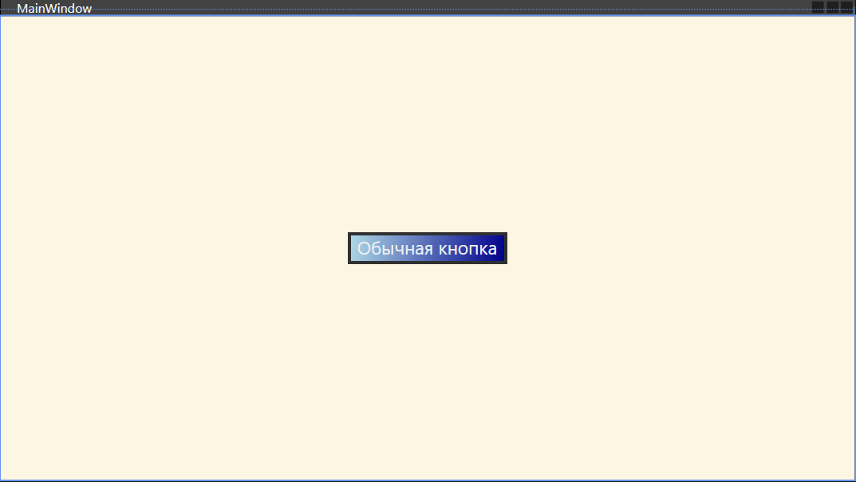  
  
GradientWindow  
  
<Window x:Class="Lab_1_WPF.GradientWindow"

xmlns="http://schemas.microsoft.com/winfx/2006/xaml/presentation"

xmlns:x="http://schemas.microsoft.com/winfx/2006/xaml"

xmlns:d="http://schemas.microsoft.com/expression/blend/2008"

xmlns:mc="http://schemas.openxmlformats.org/markup-compatibility/2006"

xmlns:local="clr-namespace:Lab_1_WPF"

mc:Ignorable="d"

Title="GradientWindow" Height="450" Width="800">

<Grid>

<Button>

<Button.Background>

<LinearGradientBrush StartPoint="0,0" EndPoint="0,1">

<LinearGradientBrush.GradientStops>

<GradientStop Color="DarkBlue" Offset="0"/>

<GradientStop Color="LightBlue" Offset="0.2"/>

<GradientStop Color="LightBlue" Offset="0.8"/>

<GradientStop Color="DarkBlue" Offset="1"/>

</LinearGradientBrush.GradientStops>

</LinearGradientBrush>

</Button.Background>

</Button>

</Grid>

</Window>  
